PRACTICAL NO.

# WRITE A PROGRAM TO CREATE A WEB BROWSER IN VC++

To create a Web Browser:

- Open Visual C++. Go to file menu ,select New item. Then from the New dialog box select MFC Application Wizard.exe. Give Project name .Press Ok. Select ‘dialog based program’. Click finish .
- Select ‘Add to Project’ from Project menu and then ‘components and controls’ from Add to project item. This opens Visual C++ components and control gallery.
- Now double click the entry marked ‘Registered Active X Controls’ to open the list of Active X Controls in our system.
- One of the controls in the components and controls gallery should be Microsoft Web Browser, click that ,then click the ‘Insert’ button.
- Visual C++ asks us that which class we want for this new control’accept default suggestion C Web Browser or C Web Browser2. This adds the Web Browser at bottom in tool box.
- Drag a new control of that type to dialog window under design, sizing it as we want. This gives the new browser control the ID “IDC_EXPLORER1”.
- Go to View menu, select Class Wizard and connect a member variable to this control. Double click on it. A window will appear. Type there m_browser.
- Add a button with Caption Browser to dialog window and connect an event handler method to that button On Button1(c).
- When the user click the Browser Button ,we can navigate our web browser to www.microsoft.com . We do that with Web Browser control method Navigate()
- Void C Browser Dlg:: On Button1()
{
->m_browser_Navigate(http://www.microsoft.com0,0,0,0);
}
- This simple line is all it takes. Now our browser is ready. Run the program.(build from build menu and then execute).Now click the Browser Button .
- When we click that button ,web browser navigates to the
Microsoft home page.

OUTPUT:

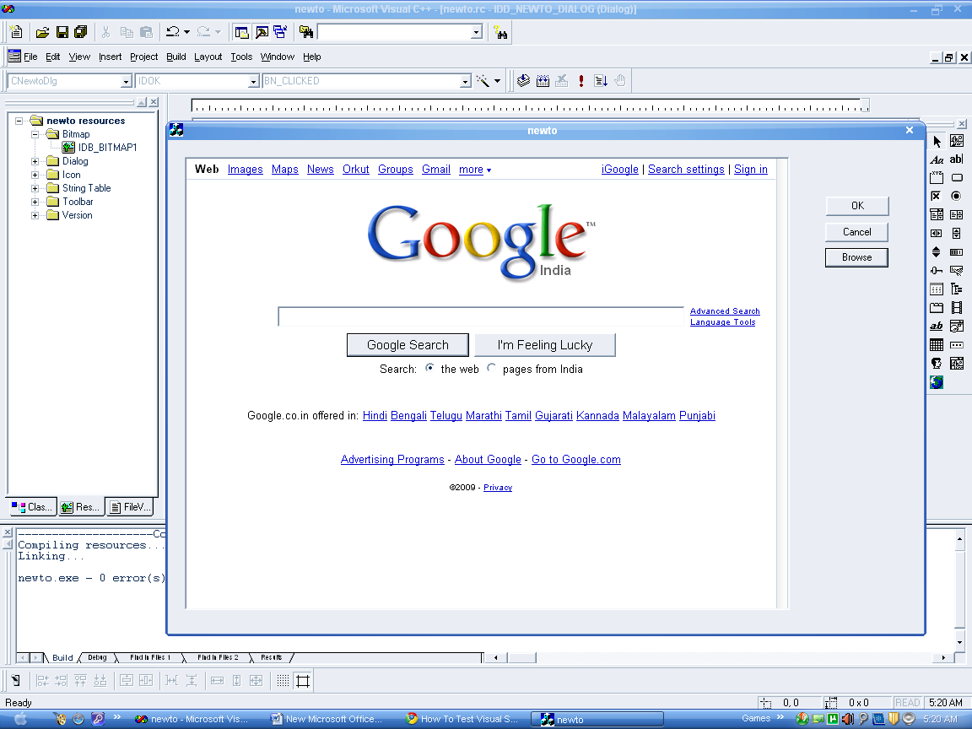

PROGRAM NO.
#WRITE A PROGRAM FOR CREATING AN ACTIVE X CONTROL

Steps for creating an active x control:

- Start VC++ now to create the boxer program .This time in file->new->MFC ActiveX Control Wizard and give project name boxer and click ok. Now accept all the default finish .
- Code for this new control appear in the files Boxerctrl .h and Boxerctl.cpp . For example there is an OnDraw() method in which we draw our control.
- We call the OnDraw() method in Boxerctl.cpp and remove the “pDC->ellipse(r c Bounds)”; line .Now go to file view class ->open boxer file ->Boxerctrl .h.
- Now we are dividing the control up into four rectangle naming those rectangle box 1 to box 4 and add coding for them in Boxer ctrl .h under ~(Boxer ctrl .c);
-> C Rect box 1;
-> C Rect box 2;
-> C Rect box 3;
-> C Rect box 4;
-> Boolean fill 1 ;
-> Boolean fill 2 ;
-> Boolean fill 3 ;
-> Boolean fill 4 ;

- Now add coding in OnDraw() method which is constructor CBoxerCtrl under pDC-> fill Rect (………)
->box 1= CRect(rcBounds.left ,rcBounds.top , rcBounds.right/2 ,rcBounds.bottom/2);
-> box 2= CRect(rcBounds.left ,rcBounds.bottom , rcBounds .right/2 , r c Bounds .bottom/2);
-> box 3= CRect(rcBounds.right,rcBounds.top ,rcBounds.right/2 ,rcBounds.bottom/2);
->box 4= CRect(rcBounds.right,rcBounds.bottom,rcBounds.right/2,rcBounds.bottom/2);
->p dc->Rectangle (&box 1);
->p dc->Rectangle (&box 2);
->p dc->Rectangle (&box 3);
->p dc->Rectangle (&box 4);
->if(fill 1) pdc ->FillSolidRect(&box 1, RGB(0,0,0));
->if(fill 2) pdc ->FillSolidRect(&box 2, RGB(0,0,0));
->if(fill 3) pdc ->FillSolidRect(&box 3, RGB(0,0,0));
->if(fill 4) pdc ->FillSolidRect(&box 4, RGB(0,0,0));
6. Now add On WM_LButtonDown () method from class wizard to
our Active X control and add coding under
void (Boxer ctrl :: On L Button Down (UINT ,n Flag,C Point……)
->fill 1= box 1 .Pt In Rect (point);
->fill 2= box 2 .Pt In Rect (point);
->fill 3= box 3 .Pt In Rect (point);
->fill 4= box 4 .Pt In Rect (point);
7. We set the flags false in the control ‘s constructor under
BoxerCtrl :: Boxer ctrl ()
-> fill 1=fill 2 =fill 3= fill 4=false;
Now our program is ready to test.
- To test “Boxer” start by selecting the build Boxer.OCX item in the build menu to create Boxer.OCX and register that with a Windows . Next select the Active X control test container item in the tool Menu . Now select the Insert new control item in the test container’s edit menu and double click the boxer control in the insert control box that appear . This Insert the Active X control in the test container. You can click one of the boxes in the control , it will shaded black.

OUTPUT:

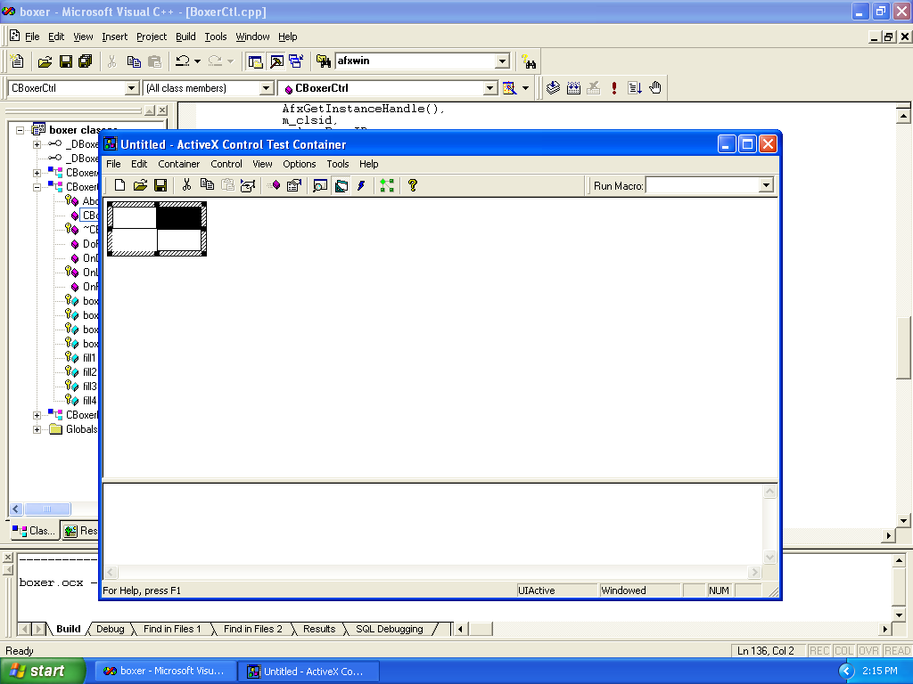

PROGRAM NO.

# WRITE A PROGRAM FOR CREATING THE WRITER PROGRAM (SERIALIZING)

Steps for creating the writer program:

- Go to VC++6.0 and open it .Now go to file menu in upper left most corner of Screen . select new. Go to MFC app wizard (exe) .Give the project name “Writer” and click ok.
- Now select single document (SDI) radio button and click on finish and then ok. This will create a writer class .
- Now go to the file view of writer class window . Click on the + sign of writer files .Open header files by clicking on + sign and double on writer doc .h /header file . This will open the wizard code of “Writerdoc .h” file.
- Now add the following code
//Attribute
Public:
->CString StringData;
//operations
Public:
- Now go back to class view to initialize that object to the empty string in the document’s constructor . Open writer class by clicking on + sign . Now click on “C Writer Doc” + sign and double click on “CWriter.Doc” constructor and add the code under
CWriterDoc :: CWriterDoc ()
{
String Data=””.
This code is added in writerDoc.cpp file .
- Now go to view menu . Select class wizard . Select message map tab . Select “CWriter View” in “class name” box. Now go to message window and double click on WM_CHAR to add it to member function list . Now double click on OnChar() member function which we just add in member function list . This will open “Writer View.cpp” window . Add the following code at the place of “To Do :Add your message handler code here”.
-> CWriterDoc *pDoc=GetDocument ();

-> ASSERT_VALID (pDoc);
-> pDoc -> StringData += n Char;
-> Invalidate ();
7. Now go to “C WriterView” in writer class and click on + sign
and double click on
“On Draw(CDC *pDC) and add the following code under
ASSERT_VALID (pDoc);
->pDC -> TextOut (0 ,0 ,pDoc->StringData);
Now the program can read and display character that the
user type , and it store those character in the StringData
object. Now we have to store and retrieve our
program’ s data. i.e The String Data object to and from disk
8. Serializing the String Data Object :-
Now go to Writer.Doc.Cpp file window or click serialize
(C Achive & a r ) which is a part of C Writer Doc class and
add the arrow marked code between in built code.
VoidCWriter Doc :: Serialize (C Archive & a r )
{
If (ar. Is Storing ())
{
-> a r <<StringData;
}
Else
{
-> a r >> StringData;

Our program is ready . [But when user adds more data to the String Data Object , we can let the document know that the data it is to store has been modified]. But if the user quits before saving the new data to disk ,the program will pop up a dialog box of the kind “Save changes to document 1”.

- No go to C Writer View Class and double click on OnChar()
method. This will open “WriterView.cpp” file window . Add the following code under Invalidate () method
-> pDoc -> SetModifiedFlag ();
Now we are ready to the program . We have to typed some
text into the writer program and we are ready to save it to
disk .
Go to file menu of the untitled Writer window . Select the
Save As item . The Save as dialog box appear. We save the
program’s data in a file named text .dat. The user can now
read the file back in by selecting the Open item in the file
menu, which make the open dialog box appear . Here we
select text.dat and read the file back in .

- There are one or two things to add this program. First ,we should add some code to clear the text in String Data when the user select the new item in the file menu to create a new document ; We do that in the document’s On New document () method . For this go to C Writer.Doc class , double click on On New Document ()method. Writer Doc.cpp file will open .
Add the Arrow marked code under
BOOL C Writer Doc :: On New Document ()
{
.
.
.
return FALSE;
-> StringData =””;
return TRUE ;
}
- If we had a number of object to serialize , we simply load them back into the program in the same order that we stored them to start with . For this go to serialize () method and replace the “a r << String Data” with ”a r >>String data”

If(ar.IsStoring())
{

- a r << Data 1;
- a r << Data 2;
}
Else
{

- a r << Data 1;
- a r << Data 2;
In this way we are able to serialize the number of object s not just one.

OUTPUT:

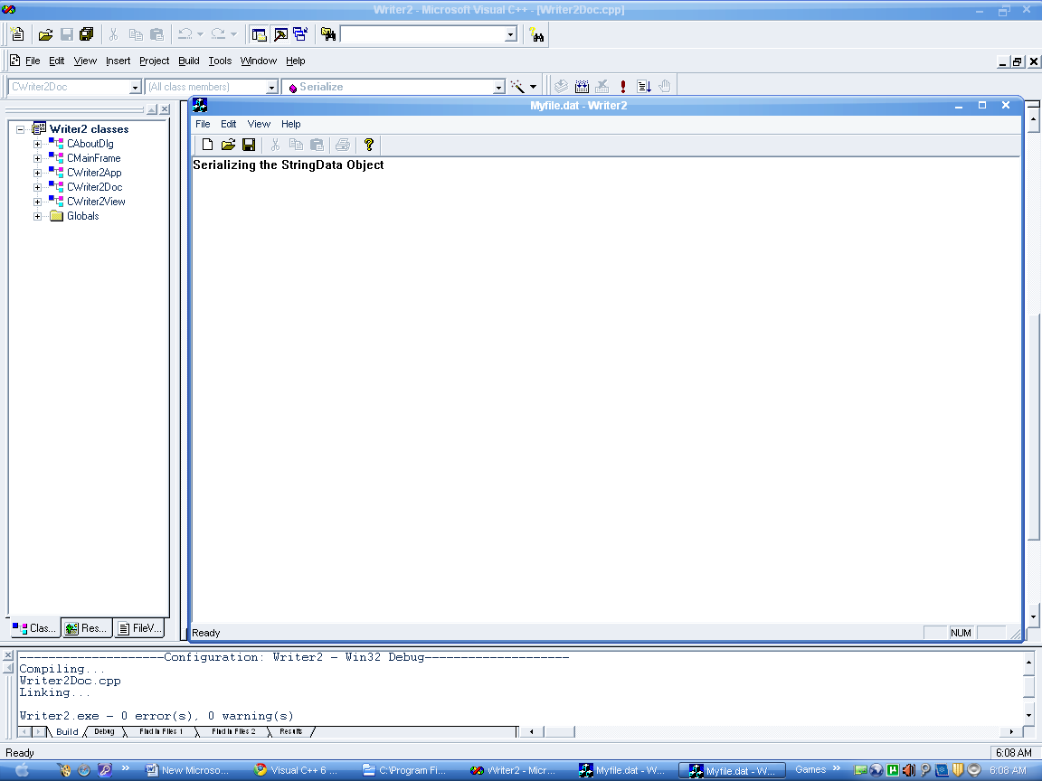

PROGRAM NO.

#WRITE A PROGRAM FOR FILE HANDLING

Steps for file handling:

- Open VC++ 6.0. Go to file menu.Select New ->MFC AppWizard(exe).Give project Name filehandling. Click ok.Select dialog based program radio button and click on finish and then on Ok button. A dialog box with a tool box will appear.

Dividing a file into records
- Go to File view.Click on + sign of filer files. Now click on + sign of header files and double click on “filehandlingDlg.h header file.
Add code under
Protected:
HICON m_hIcon;
->char OutString[4][20];
->char InString[20];

Initializing filer’s data

- Go to class view, open the filehandling classes by clicking on +sign. Now open CFilehandlingDlg class and double click on OnInitDialog()method.FilehandlingDlg.cpp window will open.
BOOL CFilehandlingDlg::OnInitDialog()
{
CDialog::OnInitDialog();
->strcpy(OutString[0],”welcome ”);
->strcpy(OutString[1],”to ”);
->strcpy(OutString[2],”file ”);
->strcpy(OutString[3],”handling ”);

- Drag and drop the edit box to dialog box and delete the To
Do box from dialog box.Drag and drop a button between two edit boxes and give them size as you want.Right click on the button, go to properties and write in caption box” write and read the file”.
Go to view menu->class wizard->member variable->control
IDs window
->double click on IDC_EDIT1.Type member variable name
m_text1 and similarly m_text2 and click ok.
- Now add the following code under
Strcpy(OutString[3],”handling”);
->m_text1=CString(OutString[0])+CString(OutString[1])
+CString(OutString[2])+CString(OutString[3]);
->UpdateData(false);

Writing a file

- Now go to filehandling dialog box. Double click on “write and read file” button. A filehandlingDlg.cpp file will open. Here add code under
voidCFilehandlingDlg::OnButton1()
{
->CFile OutFile(“data.dat”,CFile::modeCreate CFile::modeWrite);
->for(int loop_index=0;loop_index<4;loop_index++)
->{
->OutFile.Write(OutString[loop_index],20);
->}
->OutFile.Close();
->CFile InFile(“data.dat”,CFile::mode Read);
->for (loop_index=0;loop_index<4;loop_index++)
->{
->InFile.Seek(20*loop_index,CFile::begin);
->int NumberCharacters=InFile.Read(InString,20);
->m_text2+=CString(InString);
->}
->Update Data (false);
InFile.Close();
- Run

OUTPUT:

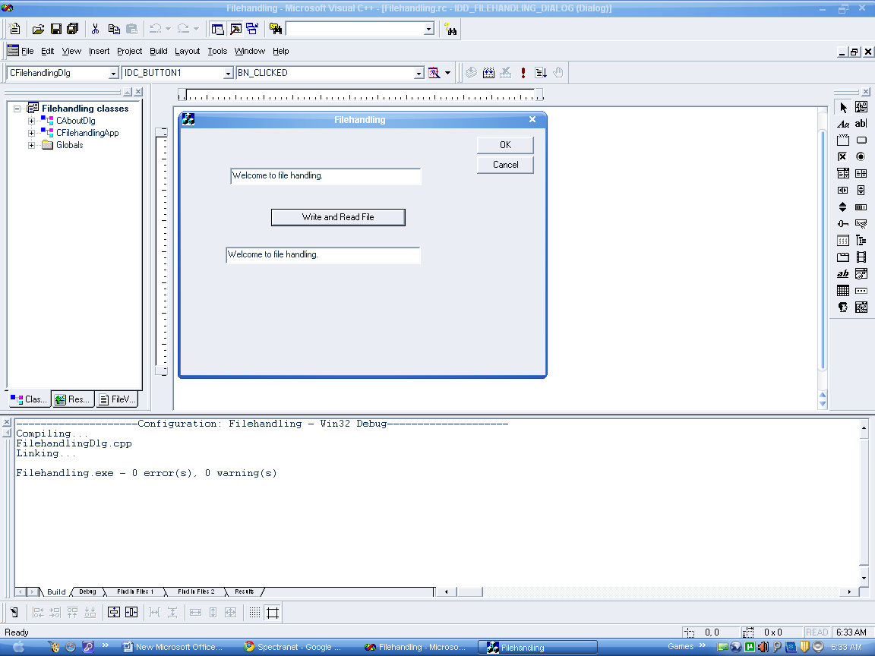

PRACTICAL NO.
WRITE A PROGRAM TO CREATE CHECKBOXES
To create checkboxes:
1.Open VisualC++ ,select new item from file menu and then create a dialog based window using application wizard.
2.Select MFCAppWizard.exe and give project name “Checkbox”,click ok then select dialog based and click on finish and then ok.
3.Now open dialog box for our main window , from resource view select ID=IDD_CHECKS_DIALOG in dialog editor.
4.Delete “TODO:Place dialog control here”(just select that label and press delete).
5.Drag three chekboxes and one text box to our dialog window from dialog’s editors toolbox (checkbox is fourth tool down on left).Dialog editor gives checkboxes captions Checkbox1, chekbox2&chekbox3.
Connecting checkbox to code:
6.Open classwizard and find three chekboxes IDC_CHECK1, IDC_CHECK2 & IDC_CHECK3.Connect these IDvalues one by one by clicking and then double clicking BN_CLICKED message in message box.
7.Now connect a member variable to text in textbox which we will name m_text.
Click on add variable and write m_text.
8.To display the text in text box we will add following code to the three checkboxes as follows:
void CCheckboxDlg::OnCheck1() { ->m_text="checkbox1 is clicked"; ->UpdateData(false); } void CCheckboxDlg::OnCheck2() { ->m_text="checkbox2 is clicked"; ->UpdateData(false); } void CCheckboxDlg::OnCheck3() { ->m_text="checkbox3 is clicked"; ->UpdateData(false); }
9.Build and Execute

OUTPUT:
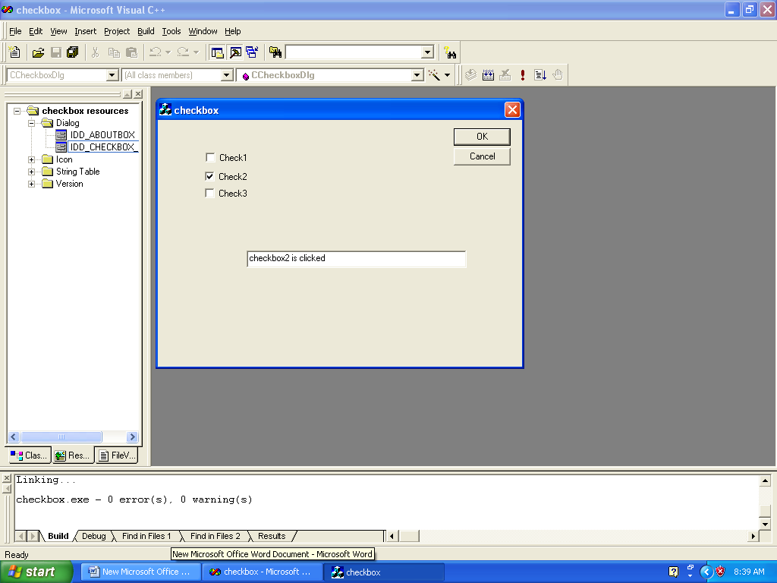

PRACTICAL NO.
WRITE A PROGRAM TO CREATE RADIO BUTTONS To create radio buttons:
To create checkboxes:
1.Open VisualC++ ,select new item from file menu and then create a dialog based window using application wizard.
2.Select MFCAppWizard.exe and give project name “radio ”,click ok then select dialog based and click on finish and then ok.
3.Now open dialog box for our main window , from resource view select ID=IDD_RADIOS_DIALOG in dialog editor.
4.Delete “TODO:Place dialog control here”(just select that label and press delete).
5.Drag three radio buttons and one text box to our dialog window from dialog’s editors toolbox (radio button is fourth tool down on right).Dialog editor gives radio buttons captions radio1 ,radio2 & radio3.
Connecting checkbox to code:
6.Open classwizard and find three Connecting checkbox to code:
6.Open classwizard and find three radio buttons IDC_RADIO1, IDC_ RADIO 2 & IDC_ RADIO 3.Connect these IDvalues one by one by clicking and then double clicking BN_CLICKED message in message box.
7.Now connect a member variable to text in textbox which we will name m_text.
Click on add variable and write m_text.
8.To display the text in text box we will add following code to the three radio buttons as follows:
void C RadioDlg::OnRadio1() { ->m_text="Radio1 is clicked"; ->UpdateData(false); } void CRadioDlg::OnRadio2() { ->m_text="Radio2 is clicked"; ->UpdateData(false); } void CRadioboxDlg::OnRadio3() { ->m_text="Radio3 is clicked"; ->UpdateData(false); }
9.Build and Execute

OUTPUT: 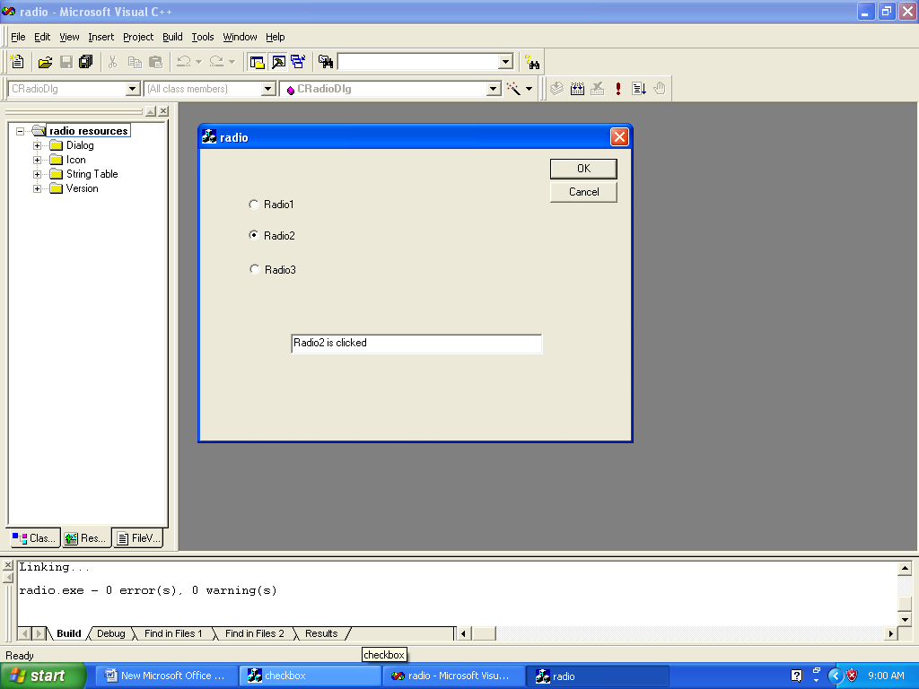

PRACTICAL NO.
WRITE A PROGRAM TO CREATE LISTBOX To create list box:
1.Open VisualC++ ,select new item from file menu and then create a dialog based window using application wizard.
2.Select MFCAppWizard.exe and give project name “lists”,click ok then select dialog based and click on finish and then ok.
3.Now open dialog box for our main window , from resource view select ID=IDD_LISTS_DIALOG in dialog editor.
4.Delete “TODO:Place dialog control here”(just select that label and press delete).
5.Drag one list box and one text box to our dialog window from dialog’s editors toolbox (list box is fifth tool down on right).
6.Next add two labels,which are also called static text. Drag a label to the top of listbox and then simply type the text :”Double click an item:”.This text will appear in the label.Add another label on the top of the text box in which we will indicate the user’s selectionand give label the text “You Chose”.
Add items to the list box
7.Start class wizard now and select member variable tab.
8.Select the IDC_LIST1 item in the controls IDs box, and then click Add Variable button. This opens the Add Variable box.
9.Connect member variable, m_list,to the listbox,IDC_LIST1. Type the name m_list in the member variable Name box. Make sure you select Control in category box
10. Now click OK button to close the Add Member Variable box.This adds member variable m_list, of CListBox,to our program,now we have a way to our list box in code:as m_list.
Initializing the data in a list box
11.Add following code to the OnInitDialog()method:
BOOL CListsDlg::OnInitDialog() { CDialog:: OnInitDialog() ->m_list.AddString(“Item 01”); ->m_list.AddString(“Item 02”); ->m_list.AddString(“Item 03”); ->m_list.AddString(“Item 04”); ->m_list.AddString(“Item 05”); ->m_list.AddString(“Item 06”); ->m_list.AddString(“Item 07”); ->m_list.AddString(“Item 08”); ->m_list.AddString(“Item 09”); ->m_list.AddString(“Item 10”); }
12.Connect a member variable m_text.Open class wizard ,select listbox,IDC_LIST1,and double click the LBN_DBLCLICK message in message box.Classwizard suggest the name OnDblclkList1() ,accept that name and click OK.
Determining which item is selected in a list box
13.Add following code :
Void ClistsDlg::OnDblclkList1() { ->m_list.GetText(m_list.GetCurSel(),m_text); ->UpdateData(false); }
14.Build and Execute

OUTPUT:
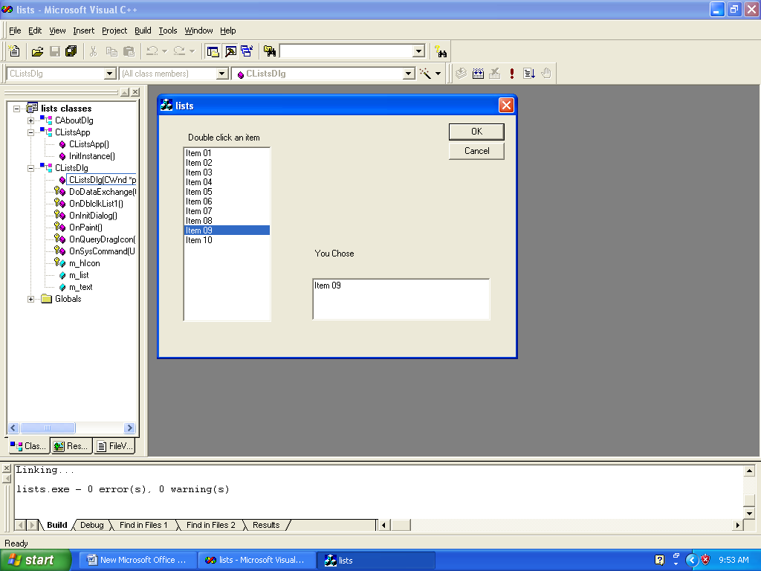

PRACTICAL NO.
WRITE A PROGRAM TO CREATE COMBO BOX To create combo box:
1.Open VisualC++ ,select new item from file menu and then create a dialog based window using application wizard.
2.Select MFCAppWizard.exe and give project name “combos”,click ok then select dialog based and click on finish and then ok.
3.Now open dialog box for our main window , from resource view select ID=IDD_COMBOS_DIALOG in dialog editor.
4.Delete “TODO:Place dialog control here”(just select that label and press delete).
5.Drag one combo box and one text box to our dialog window from dialog’s editors toolbox .
6.Next add two labels,which are also called static text. Drag a label to the top of combo box and then simply type the text :”Choose an item:”.This text will appear in the label.Add another label on the top of the text box in which we will indicate the user’s selectionand give label the text “You Chose”.
Add items to the combo box
7.Start class wizard now and select member variable tab.
8.Select the IDC_COMBO item in the controls IDs box, and then click Add Variable button. This opens the Add Variable box.
9.Connect member variable, m_combo,to the combobox,IDC_ COMBO. Type the name m_combo in the member variable Name box. Make sure you select Control in category box
10. Now click OK button to close the Add Member Variable box.This adds member variable m_ combo, of CcomboBox,to our program,now we have a way to our list box in code:as m_combo.
Initializing the data in a combo box
11.Add following code to the OnInitDialog()method:
BOOL CComboDlg::OnInitDialog() { CDialog:: OnInitDialog() ->m_ combo.AddString(“Item 01”); ->m_ combo.AddString(“Item 02”); ->m_ combo.AddString(“Item 03”); ->m_ combo.AddString(“Item 04”); ->m_ combo.AddString(“Item 05”); ->m_ combo.AddString(“Item 06”); ->m_ combo.AddString(“Item 07”); ->m_ combo.AddString(“Item 08”); ->m_ combo.AddString(“Item 09”); ->m_ combo.AddString(“Item 10”); }
12.Connect a member variable m_text.Open class wizard ,select combo box,IDC_COMBO,and double click the LBN_DBLCLICK message in message box.Classwizard suggest the name OnDblclkList1() ,accept that name and click OK.
Determining which item is selected in a list box
13.Add following code :
Void CComboDlg::OnDblclkCombo1() { ->m_combo.GetText(m_combo.GetCurSel(),m_text); ->UpdateData(false); }
14.Build and Execute

OUTPUT:
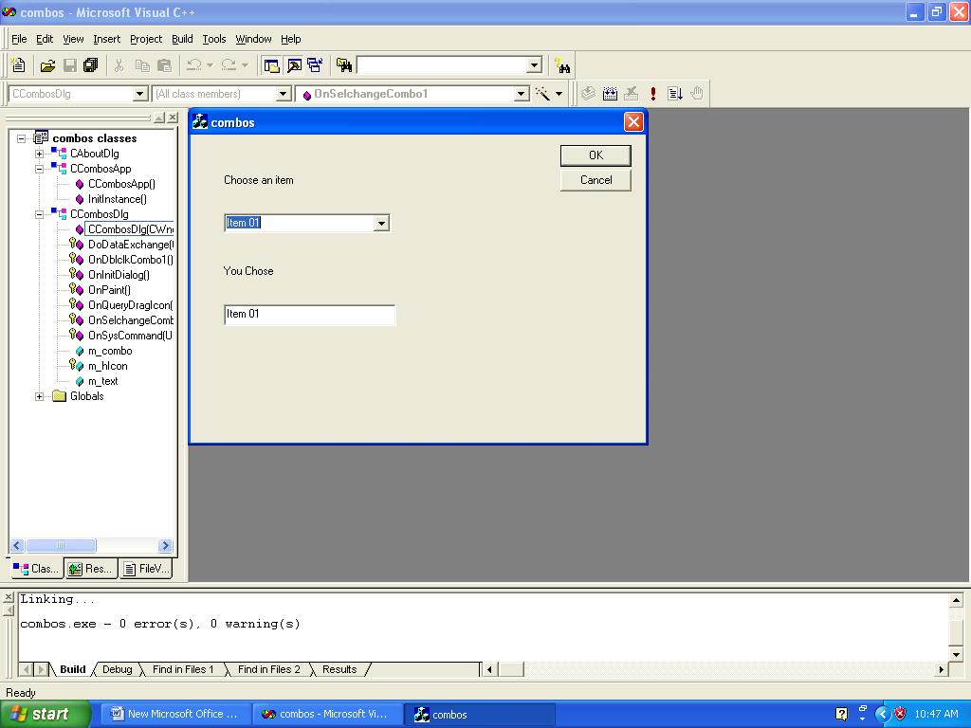

PRACTICAL NO-

#HOW TO CREATE A SLIDER

1. Create a dialog-based appWizard(exe) program and name it
sliders.
2. Add a text box, two labels and a new slider ctrl from tool box .
The slider’s ID value is IDC-SLIDER1.This we will get by
opening the dialog folder.
3. Now go to class Wizard to add a new member variable of class
CSlider to your program. Double click onIDC_SLIDER1.
Select category ctrl and ctrl and add m_slider .Now press ok
and also add the member variable m_text to edit box/text box.
4. Initializing a Slider ctrl:-

Now we will set the range of the slider .In our example, we set
the range from
1 to 100 using CSlider ,set Range Min(),set
Range Max() methods.
Now double click on the Slider, a window will open, press ok
option then code window will open. Now add code under
BOOL CSliderDlg::OnInitDialog()
{
CDialog::OnInitDialog();
->m_slider.SetRangeMin(1,false);
->m_slider.SetRangeMax(100,false);
->m_text = “1”;
-> UpdateData(false);
5. Handling the Slider events:-

When the user moves the Slider’s thumb, it passes a
WM_HSCROLL.Using Class Wizard, connect WM_HSCROLL
to the OnHScroll() method (for vertical slider , you would use
OnVScroll()).Be sure that the object ID for CSlidersDlg is
selected in the ClassWizard when you add the handler .Also
class name should be CSliderDlg . Now double click on the
WM_HSCROLL which appear in message window .now double
click on added handler OnHScroll(). This will open a code
window.
6. Now add the code under
Void CSiderDlg::OnHScroll(UNIT nSBCode,UNIT nPos ,
CScrollbAR* pScrollBar)
{
if (nSBCode = = SB_THUMBPOSITION)
{
-> m_text.Format(“%ld”,nPos);
-> UpdateData(false);
}
else
{
CDialog::OnHScroll(nSBCode, nPos, pScrollBar);
}
}
7. Now run the program code for this program will appear in slidersDlg.h and slidersDlg.cpp .

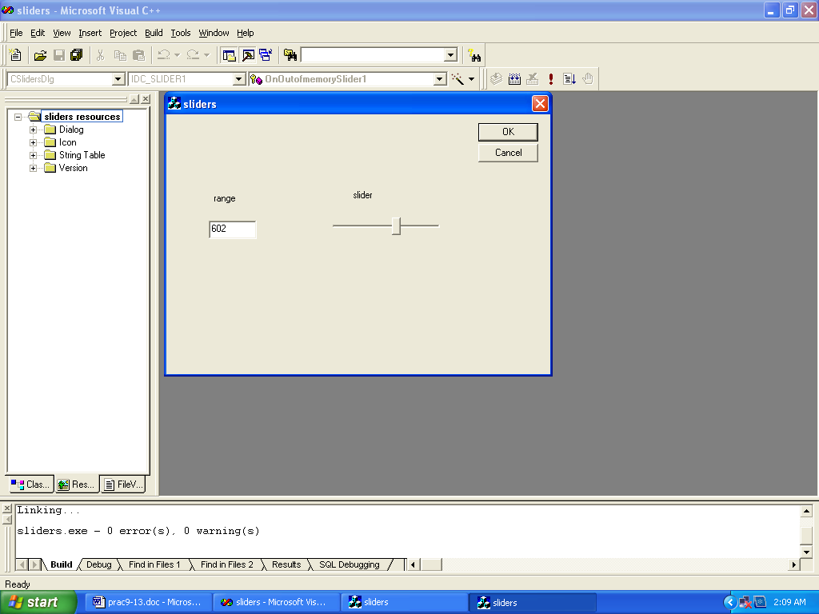

PRACTICAL NO.1

# WRITE A PROGRAM TO CREATE A SIMPLE WINDOW

To create a simple window:

- Open Visual C++ and click the New item in the File menu, opening the New dialog box.
Now select the Win 32 Application entry in the New dialog box and give the project name ‘Sample 1’.
- Now we click the Ok button. This opens a Win 32 application box, click the Finish button in this box.
- From File menu select New item and then from New dialog box select C++ source file,check the box for ‘Add to Project’ and give file name ‘Sample1.cpp’.
- Select Settings from Project menu and then select the ‘Use MFC in shared DLL’ from a drop down list. Click Ok
- Now we will add the following C++ source code to the program in the file “Sample1.cpp”:

#include<afx win.h>
class myframe:public framewnd
{
public:myframe()
{
create (0,"hello MFC");
}
};
class myapp:public cwinAPP
Public:
int InitInstance()
{
myframe *p;
P=new myframe;
p->show window (3);
m_pmainwind = p;
return 1;
}
};
myapp a;
- From build menu Select build ‘ Sample1.exe’.
- And then Select Execute ‘Sample1.exe’ from build menu.

OUTPUT:

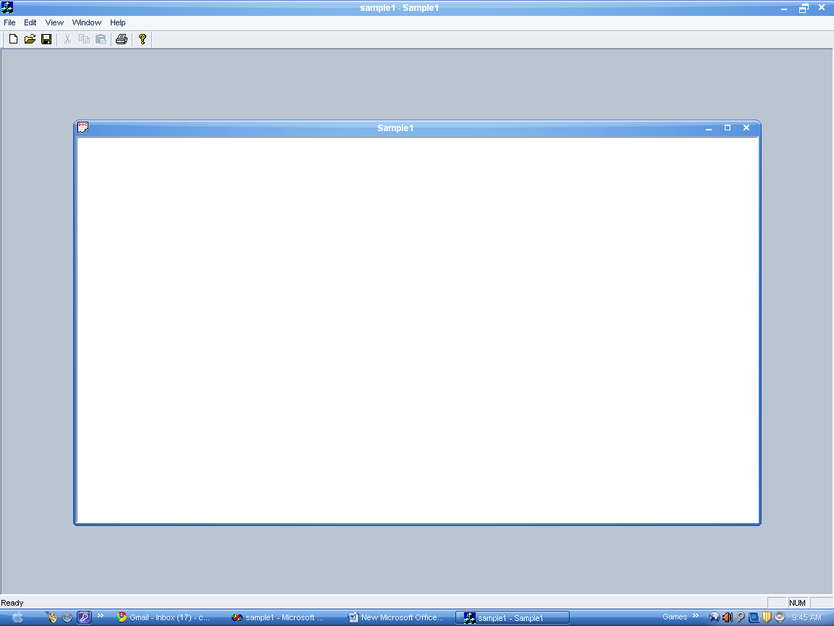

PRACTICAL NO.2

# WRITE A PROGRAM TO CREATE A HELLO PROGRAM USING MFC

- Select new from file menu.
- Click on project Tab.
- Select MFC AppWizard(EXE).
- Enter “HELLO1” as project name and press OK.
- Select single document and press next.
- Select none for database support and press next.
- Select none for compound document support and remove
support for Active X Control & press next.
- Deselect all the checkboxes when it ask for what features
would we like to include, press next.
- Style of project is MFC Standard. Select yes for generate
comment option and also select as a shared DLL option.
Press next.
- Now all the files are created. Press FINISH.
- Click the class view tab.
- Find entry for “CHello1View” class.
- Click on small + sign next to that entry to open it. This
display the methods in this class.
- Find the entry for OnDraw() and double click it. This
open the OnDraw() in the next editor.
- Now add these lines to code:
void CHELLO1View::OnDraw(CDC* pDC)
{
CString Welcome_String="Hello World";
CHELLO1Doc* pDoc = GetDocument();
ASSERT_VALID(pDoc);
pDC->TextOut(0,0,Welcome_String);
}

OUTPUT:

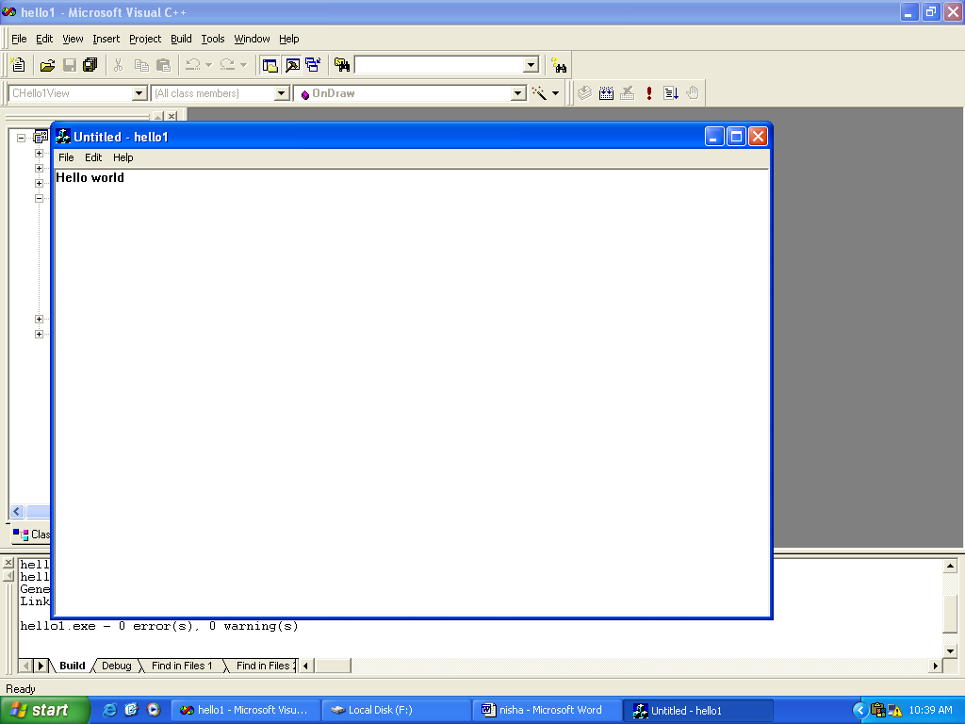

PROGRAM NO. 3
#WRITE A PROGRAM FOR READING KEYSTROKES

Steps for reading keystrokes:

- Select new from file menu.
- Click on project Tab.
- Select MFC AppWizard(exe).
- Enter “Key”project name and press OK.
- Select single document and press Finish.
- In file View press on small + sign which is in front of
Header file then select “KeyDoc.h”.
- Add the following lines:
  - DECLARE_DYNCREATE(CkeyDoc)
  - CString StringData;
- Move to ClassView and press on small + sign which is in
front of constructor which will
  - Create the .cpp file and add the lines:
  - ->CKeyDoc::CKeyDoc()
    - {
    - StringData = " ";
    - }
- Go to View Object ,press ClassWizard and then message
maps; select CKeyView and double click on WM_CHAR
then click on OnChar and add the lines:
  - void CKeyView::OnChar(UINT nChar, UINT nRepCnt, UINT nFlags)
    - {
    - CKeyDoc* pDoc= GetDocument();
    - ASSERT_VALID(pDoc);
    - pDoc->StringData += nChar;
    - Invalidate();
    - CView::OnChar(nChar, nRepCnt, nFlags);
    - }
- Click on CKeyView and click on OnDraw() and add the lines:

  - void CKeyView::OnDraw(CDC* pDC)
    - {
    - CKeyDoc* pDoc = GetDocument();
    - ASSERT_VALID(pDoc);
    - pDC->TextOut(0,0,pDoc->StringData);
    - }

OUTPUT:

